Manual Sliding Fire Door
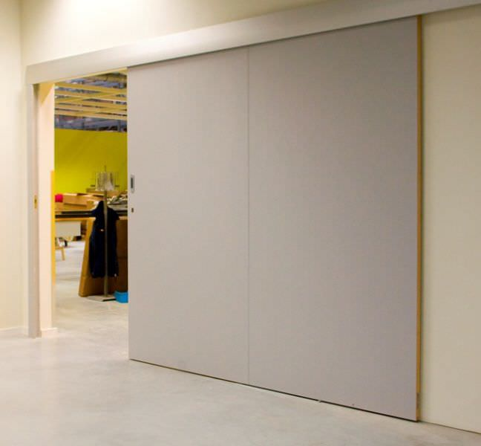
Sr. No. | Description | Qty. | Rate / Door
A | Radiant’ Fire Resistant Manual Sliding Type (2 Hour fire rated) made up of Two 1.20mm thick GI sheet, 40mm thick with infill material Mineral Wool complete with all fixing arrangements including guide rail AS PER BS 476 PART- 20 & 22. The Door shall be duly painted and the specification shall meet as per IS. (Accessories Inclusive).  As per the norms an overlapping of 100 mm in height and 200 mm in width is considered while calculating the sizes of the doors and is mandatory to restrict fire from escaping from the gaps between the wall and the shutters.
1 | Wall Opening Size: (W) x mm  Door Dimension Size: (W) x (H)



